Surrealism

- A cultural movement expressed through art, literature and politics.
- Focuses of ideas of chaos and unconscious desires –>things we want that we don’t know we want…? expresses the imagination revealed in dreams, free of the conscious control of reason and convention.
- Digging into the unconscious mind to find inspiration for artistic and political creativity.
- Rejection of overly rational thoughts would lead to superior ideas and expressions
- “Surrealist Manifestos” –> documents published by surrealist movement (Andre Breton (leader of surrealist movement))
- Defined surrealism as a pure state of mind that allows someone to express their thoughts freely
- Regardless of encumbrance of rational thought and societal norm???
- Trying to introduce more open and free concepts of thinking, being aware of oneself without being influenced by the outside world.
- Wanted to use art to show the inner workings of their minds –> particularly in areas concerning sexuality or violence (considered frequently oppressed in society)
- Wanted to create work that makes the viewer think and show the inner workings of the mind.
- Often used dreams and nightmares as inspiration

Artwork:
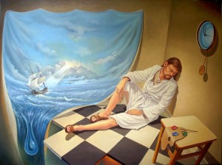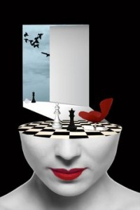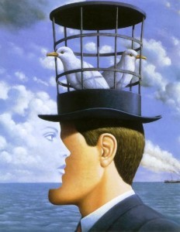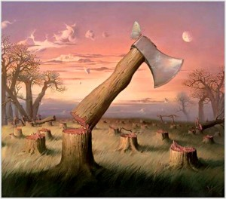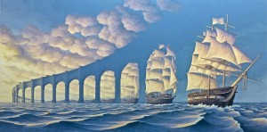

SURREAL MUSIC PIECE: PIERRE SCHAEFFER & PIERRE HENRY: ORPHÉE 53
https://www.youtube.com/watch?v=XJq3jItducg

