Romanticism flourished in Europe between 1789 and 1843.

- The glorification of the "Natural Man" and the "Noble savage", the primitive and untutored personality. Glorification of the past and nature.

- Individualism

- Social Equality

- Creation from nothingness

- The spontaneous over flow of ones feelings

- Emotion

- 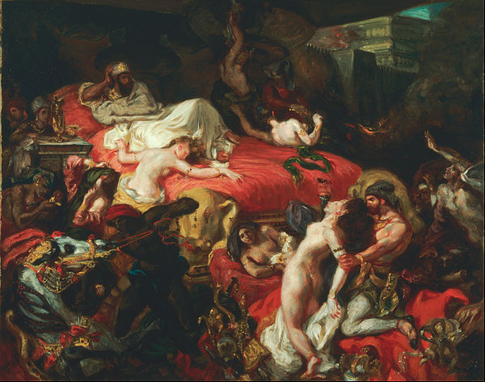Eugène Delacroix, Death of Sardanapalus, 1827

- Lord Byron- He created an immensely popular Romantic hero—defiant, melancholy, haunted by secret guilt—for which, to many, he seemed the model.

- The Robbers 1782- Emotive language"Schiller raises many disturbing issues in the play. For instance, he questions the dividing lines between personal liberty and the law and probes the psychology of power, the nature of masculinity and the essential differences between good and evil. He strongly criticizes both the hypocrisies of class and religion and the economic inequities of German society. He also conducts a complicated inquiry into the nature of evil."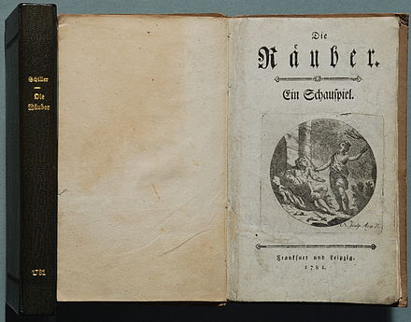

- https://www.youtube.com/watch?v=GiQq7VRQBp8

