Expressionism
“Expressionism refers to art in which the image of reality is distorted in order to make it expressive of the artist’s inner feelings or ideas” www.tate.org.uk
http://www.tate.org.uk/learn/online-resources/glossary/e/expressionism
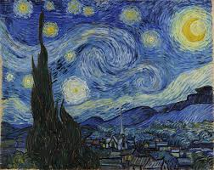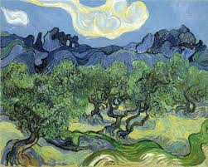
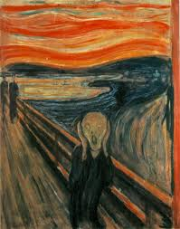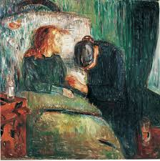
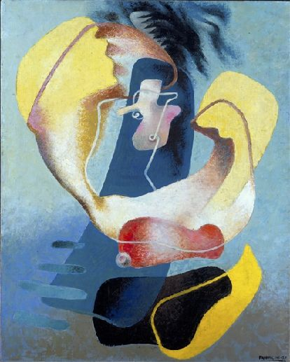
Other isms are too passive and specialized. Theatre should be forceful, urgent and emotionally charged, capturing the inner struggle each of us goes through… Dreams are a major source of truth – the dreamlike state can help illuminate life. It is time to mirror inner psychological realities instead of outer physical appearances. (Style for Actors, 2nd Edition, Robert Barton)
The movement originated in paintings (Auguste Hervé and later Van Gogh and Edvard Munch) but theatre soon followed with plays by George Kaiser and later works of Strindberg and Ibsen. The movement started as a guide for playwriting but became a mode of production.
https://www.youtube.com/watch?v=cs57UW1hOz4
Expressionism, artistic style in which the artist seeks to depict not objective reality but rather the subjective emotions and responses that objects and events arouse within a person. The artist accomplishes this aim through distortion, exaggeration, primitivism, and fantasy and through the vivid, jarring, violent, or dynamic application of formal elements. In a broader sense Expressionism is one of the main currents of art in the later 19th and the 20th centuries, and its qualities of highly subjective, personal, spontaneous self-expression are typical of a wide range of modern artists and art movements. Expressionism can also be seen as a permanent tendency in Germanic and Nordic art from at least the European Middle Ages, particularly in times of social change or spiritual crisis, and in this sense it forms the converse of the rationalist and classicizing tendencies of Italy and later of France.
https://www.britannica.com/art/Expressionism

