Dadaism
What is dadaism?
- It was created in Zurich (1916- 1923)
- It is a form of artistic anarchy born out of disgust for social, political and cultural values of time
http://www.thefreedictionary.com/dadaism:
- revolt by certain 20th century painters and writers in France, Germany and Switzerland
  - didn’t agree with the smugness traditional art and western society
- “Dada is what you can make out of yourself” Kausmann 1968
  - not only in art but also in politics
  - rejected national media and propaganda
- began in the build up to ww1
- art works were absurdities. Artist painted pointless machines and created collages of discarded materials.
- It expressed their cynicisms (an inclination to believe that people are motivated purely by self-interest; scepticism.) and conventional ideas of form and their rejection of traditional concepts of beauty
- reciting gibberish poems while wearing cardboard tubes
- designed to be misunderstood
- promoted confusion
- intended to insult and provoke
- praises irrationality
http://www.artyfactory.org/art_appreciation/art_movements/dadaism.html
- Dada was a form of artistic anarchy that challenged the social, political and cultural values of the time.
- Dada embraced elements of art, music, poetry, theatre, dance and politics.
Dada aimed to create a climate in which art was unrestricted by established values.

Summary:
- Dada was anti-establishment and anti-art movement.
- The name ‘Dada’ means ‘hobbyhorse’ or the exclamation “Yes-Yes”.
- The Cabaret Voltaire in Zurich was the birthplace of Dada.
- After the war the Dadaists relocated to Berlin, Cologne, Hanover and New York.
- The Dadaists published ‘manifestos’ and magazines to help communicate their ideas.
- The Dadaists used techniques such as automatism, chance, photomontage and assemblage.
- The Dadaists introduced the concept that an artwork could be a temporary installation.
- The Dadaists expanded the boundaries and context of what was considered acceptable as art.
- Several Dada exhibitions caused public outrage and were closed by the authorities.
- Dada influenced the development of Surrealism, Action Painting, Pop Art, Happenings, Installations and Conceptual Art.
- The main artists associated with Dada were Hugo Ball, Tristan Tzara, Marcel Janco, Richard Huelsenbeck, Jean (Hans) Arp, Raoul Hausmann, Hannah Höch, John Heartfield, Kurt Schwitters, Johannes Baargeld, Johannes Baader, Max Ernst, George Grosz, Hans Richter, Francis Picabia, Man Ray and Marcel Duchamp.

Example of a dada play
- The gas heart- Tristan Tzara
- written as a series of non sequiturs and a parody of classical drama
- one of the most recognizable plays inspired by Dadaism
https://www.youtube.com/watch?v=HQBmUHxn_1s&index=3&list=PLuo7RBR2HgundvUr8YvVwALVExjIr5Sye

a piece of music:
https://www.youtube.com/watch?v=WFP5nguGTAI

a visual work
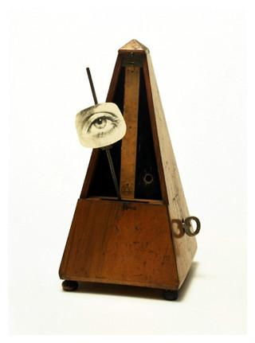http://www.artyfactory.org/art_appreciation/art_movements/dadaism.htm
MAN RAY (1890-1976) - ‘Object to be Destroyed’, 1923 (ready-made)
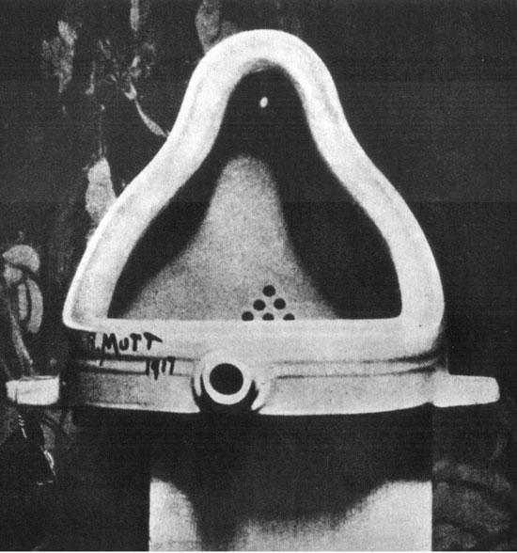
The conclusion

