Genre style: Constructivism

“A style or movement in which assorted mechanical objects are combined into abstract mobile structural forms. The movement originated in Russia in the 1920s and has influenced many aspects of modern architecture and design.” Oxford dictionaries

- Started in the late 1915s and ended in the 1930s
- Modern art movement that flourished in Russia
- Evolved as the Bolsheviks came into power
- Careful technical analysis of modern materials
- Abolish the traditional artistic concern with composition and replace it with construction
- Inspired artists in the West – rise of international constructivism which rose in Germany in the 1920s – 1950s
- Objects were created to carry out a fundamental analysis of the materials and forms of art – lead to the design of functional objects
- Ethic of “truth to materials” (capacities and the uses to which they could be put)
- Often aimed to demonstrate how materials behaved – artwork dictated by its materials and not the other way around
- This meant: goal being mass production/a new and archetypal modern style expressing the dynamism of modern life
- Seed of constructivism: desire to express the experience of modern life + desire to develop a new form of art more appropriate to the democratic and modernizing goals of the Russian Revolution
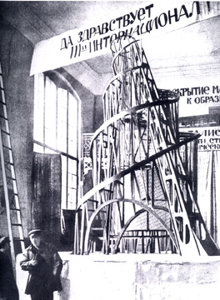
- Constructivists – constructors of a new society
- Vladimir Tatlin – father of Constructivism
Design for the Monument to the Third International (1919-1920)
- Never fully realised
- Intended to act as a conference space and propaganda centre for Comintern
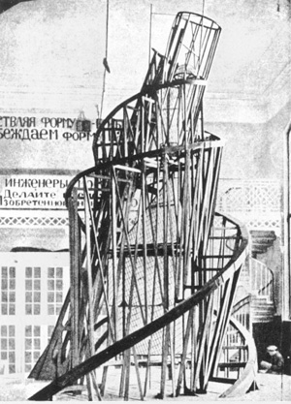

- Stage designs for Inga and Bedbug by Rodchenko

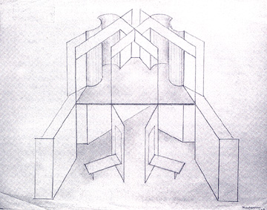
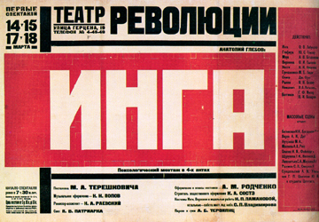

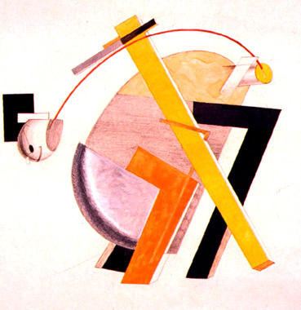
- P

- uPuppet design for the futurist play Victory over the Sun by El Lissitsky 1923

Some key premises of constructivism:
1) an interest in the use of real materials: This had characterized Tatlin�s reliefs in a concrete sense. In the work of Popova, Rodchenko, and El Lissitskii, this interest was present in a more abstract or conceptual sense.
2) an approach to design which lets the material determine the final form of the work;
3) an interest in the production of work, in the process of making it, of bringing together raw materials in order to create something real which exists on its own terms (rather than as a representation of some reality which exists outside of the art work). This interest in process is always more important than the end product, and is another relationship to the role of movement in constructivism.
4) a new understanding of the logic of space (this goes back to the interest in the fourth dimension)
5) a new understanding of the role of the spectator of the art work as someone who engages with it mentally, physically, and ideologically: the �engaged spectator� is one of the key and unique contributions of constructivism.
http://www.radford.edu/rbarris/art428/constructivism%20introduction.html
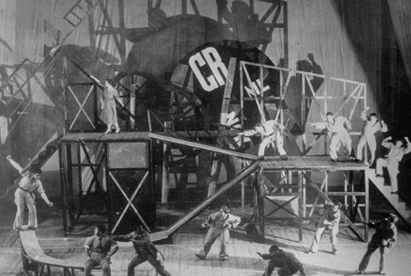
- Play by staged Meyerhold The Magnanimous Cuckold by the Belgian playwright Fernand Crommelynk
- Set was constructed by Liubov Popova
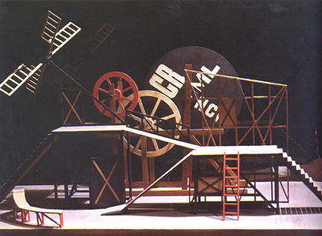
- 1922 Meyerhold’s first constructivist play
http://max.mmlc.northwestern.edu/mdenner/Drama/plays/constructivist/constructivist.html

Liubov Popova – textile design

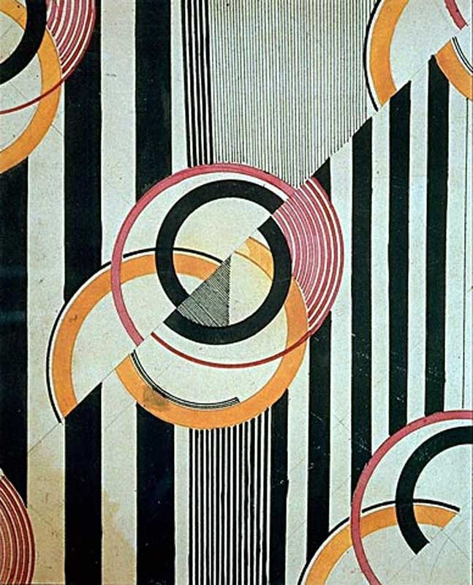

http://www.theartstory.org/movement-constructivism.htm

